Week 5 Activity

Humpreet Sahans

2024-06-21

## #Visualization 1

The Biopics dataset contains information on 761 movies released over the past ~100 years. The histogram below illustrates a clear trend of gradually increasing movie production over the years:

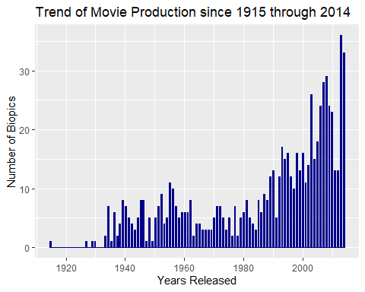

## #Visualization 2

To explore the typical subjects chosen for biographical films, we’ve analyzed various movie categories and the genders of their subjects.

As shown in the chart below, biopics often focus on figures such as criminals, musicians, athletes and historical personalities. Additionally, the data highlights a notable trend towards male subjects.

